Welcome to AT&T Mexico Digital team,

Please install the next on your local machine:

**Download from Internet:**

1. Chrome
2. WebStorm (need to ask key from Abc)

Open [https://abcprodmain.service-now.com/solveit?id=sc\_cat\_item&sys\_id=4e6a3ca80f10fa00493bbb8ce1050e77&category\_id=undefined](https://amdocsprodmain.service-now.com/solveit?id=sc_cat_item&sys_id=4e6a3ca80f10fa00493bbb8ce1050e77&category_id=undefined)

Fill the information

a.                   Business needs – I’m a member of MCSS team (Web development) and need Wecmdbstorm subscription due to project needs (YOUR PROJECT)

b.                   (Select) Machine name was not found

c.                   Example: user01

Click on ‘Submit’

1. Download Node.js from the Internet - <https://nodejs.org/en/>

<https://nodejs.org/download/release/v8.9.4/>

node -v

v8.9.3

npm -v

5.5.1

1. .npmrc file- this is for NPM

Update the file c:\users\**YOURUSER\**.npmc, with the following content:

registry=http://illin3444:8081/nexus/content/groups/2000-npm-group/

proxy=null

http\_proxy=null

https-proxy=null # [http://genproxy.corp.abc.com:8080/](http://genproxy.corp.amdocs.com:8080/)

1. Make sure that you have nodeJS environment variables set properly

Machine generated alternative text:
System variables
Variable Value
L9_AMSS_B B C:\Tef G lxC hi le\2_O\bb\cust\a mss\bb
MAVEN_HOME C:\APS\MAVEN\apache- maven-3.2.5
MAVEN_OPTS -XmslO24m -Xmx2048m -XXPermSize=512m
MW HOME C:\APS\wlsl 21 20
NODE_HOME C:\Program Files\nodejs\
NODEJS_HOME C:\Program Files\nodejs\
NUMBER_OF_PROCESSORS 4
ORACLE_HOME O:\orall2O2w ____
r i r. i .

1. For install generator go to Cmd : npm i -g --verbose generator-digital-module-att  
   [http://10.235.244.111/delivery-uxf-guidelines/generanpm listte-new-widget/](http://10.235.244.111/delivery-uxf-guidelines/generanpm%20listte-new-widget/) - manual for creating widgets
2. mRemoteNG **or** putty **or** MobaXtream
3. Total commander
4. FileZilla **or** WinSCP
5. Fiddler2
6. Install Yeoman <http://yeoman.io/>

Open CMD and type: "npm install -g yo"   
after installation type in CMD

Yo -> n -> generator-digital-module-att

* test
* If yeoman installation fails due to missing dependencies, try to install prev release instead, example:

Example: npm install -g yo@2.0.0

Releases Information: <https://github.com/yeoman/yo/releases>

1. Install Redux Chrome extension - <https://chrome.google.com/webstore/detail/redux-devtools/lmhkpmbekcpmknklioeibfkpmmfibljd?hl=en>
2. Install React Chrome extension - <https://chrome.google.com/webstore/detail/react-developer-tools/fmkadmapgofadopljbjfkapdkoienihi?hl=en>

1. For the web storm add sonar lint plugin
   1. Ctrl + Alt + S --> Plugins  → browse repositories…

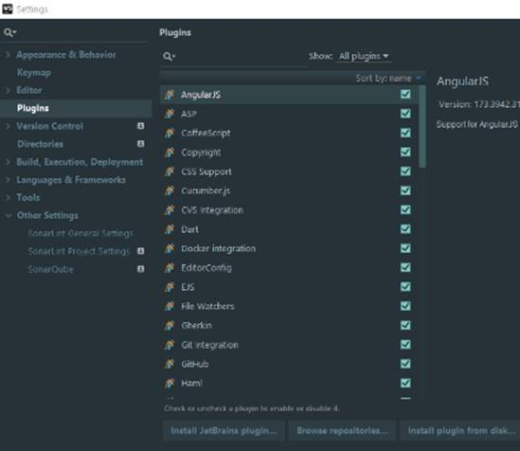

1. Search for SonarList → right click → download and install

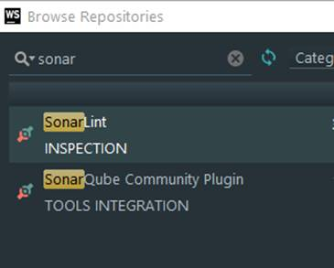

1. After installation, SonarList general settings → + (add) → put the following values:
   1. Any configuration name (illin server)
   2. select SonarQube
      1. sonarQube URL - <http://illin018:9000/>
   3. Check the "Enable proxy" click the button– type in "no proxy for:" the text "illin\*"
   4. click ok
   5. Wait for local update to finish or click "Update binding"

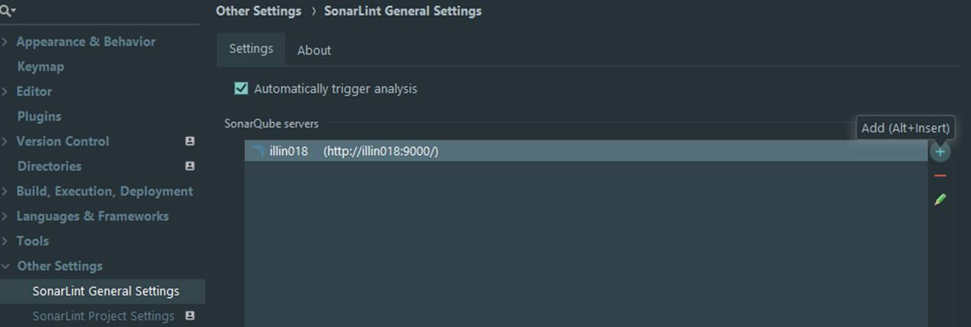

1. navigate to SonarList Project Settings on the left menu
   1. Check the "Enable binding….."
   2. in bind to server select illin018
   3. click on update project list
   4. select you project (**DIGITAL ATT-Dev-Mexico-DIGITAL**)
   5. click ok

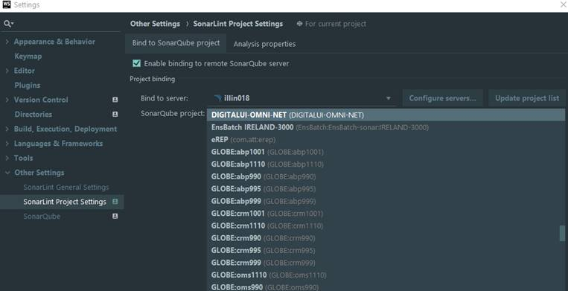

1. run inspection –
   1. View menu → tool windowns → SonarQube
   2. navigate to your project
   3. select file

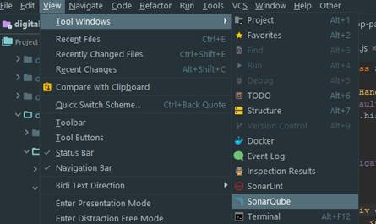

Now you have SonarLint in sync with your Server project

|  |  |
| --- | --- |
|  |  |
|  |  |

**Download from Software Catalog**

       1.    One of the text editors from Software Catalog

1. Sql Developer
2. **Perforce -**

|  |  |
| --- | --- |
| Illin2143:1666 | Dev-Mexico (//ATT/Dev-Mexico) |
| path to digital is: | //ATT/Dev-Mexico/cust/digitalExp/  //ATT/Dev-Mexico/cust/digitalUI/ |
|  |  |

Please create Perforce user through Aveksa self service.

The server details are:

**illin2143:1666**

**Depot: ATT**

Below is steps in order getting creating new user:

1.    Open the link: <https://accessit/aveksa/main>

2.     Log-in with your NT details

3.    Click on Manage Access

4.    Click on Add

5.    Change the first dropdown list to

cid:image001.png@01D353CF.96D1E4B0

6.    In the Search line type the Depot name per below depot list(where user should get user to work with) –

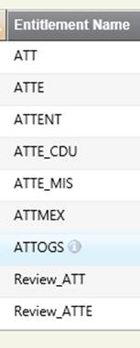

7.    Mark the check-box > click Next > click Finish

8.    Your direct manager will required to approve the request.

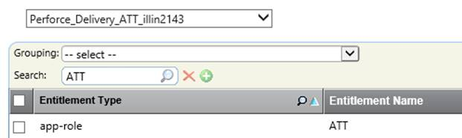

For any  additional support/help in tool please contact to Infra FLS(62000-> IT -> Infra FLS)

**Stream: Dev-Mexico**

1. Beyond Compare

**Download from my machine**

        1.    Latest Neon Eclipse [\\cplih01\APS\eclipse-java-neon-R-win32-x86\_64.zip](file:///\\cplih01\APS\eclipse-java-neon-R-win32-x86_64.zip)

        2.    ASC (Abc configurator) - [\\cplih01\APS\ASC](file:///\\cplih01\APS\ASC)

[\\MALKAAD03\ATT\_Mex\Tools](file:///\\MALKAAD03\ATT_Mex\Tools)

**AMC:**

Please open OLF to get user to AMC tool,

So you’ll be able to clone envs and provide HFs.

Raise a request for Permission in AMC - <https://goo.gl/kKaW3e>

AMC – <http://illin3444:5000/amc_illin3444/>

HD call RC is: **OGRHDW**

**Pls also open permissions in p4v for NETBrazil:**

Illin1697:1666

Machine generated alternative text:
Application Role
Name:
Application:
Entitlement
Collector:
Available For
Request:
Perforce Delivery SR 01
Perforce-Delivery-lSR-EDC
Ves
Product: NET
App Role: NET
NET
n

NET

Stream 3000-Dev

**Create a new user permission in QC**

**Please raise a request here:**

[https://abcprodmain.service-now.com/solveit?id=sc\_cat\_item&sys\_id=617ae3b03753790012b5d0d543990e39&category\_id=31329e366fa3c2009674bd5dbb3ee4d4](https://amdocsprodmain.service-now.com/solveit?id=sc_cat_item&sys_id=617ae3b03753790012b5d0d543990e39&category_id=31329e366fa3c2009674bd5dbb3ee4d4)

**RITM1672954 - Create/Modify user permissions in Quality Center**

Request for: Pavan Chaudhari  
My current location: Pune, Tower 2 \ Wing South (109-1) \ Floor 4 \ S4-143  
Preferred method for contacting me: By Lync  
Opened from ESS: Yes  
Reporting code: OGRHDW  
Additional Information: Please create a new user permission in QC for user 'pavancha' for Project 'AT&T Mexico'.  
Link: <http://alm11isr:8080/qcbin/start_a.jsp>   
domain: delivery  
Project: att\_mexico

From <[https://abcprodmain.service-now.com/solveit?id=asp\_sc\_request&table=task&sys\_id=a68faa9b37e0df085082a16043990e33&record=%5Bobject%20Object%5D](https://amdocsprodmain.service-now.com/solveit?id=asp_sc_request&table=task&sys_id=a68faa9b37e0df085082a16043990e33&record=%5Bobject%20Object%5D)>

**TO Enable RC#OGRHDW**

Send a mail to \_AT&T Mexico VMO Services <ATTMaxicoVMOServ@abc.com> with below details

Please release RC for HD call. Below are the details

·        RC to be enabled:**OGRHDW**

·        Person who needs to report on it:<Person who handle the request>

·        The relevant WH week: <week>

•         Number of Hrs:1 hr

**ATT Mex - OMS IDD - DC permission:**

<https://groupmanager/MyGroupManager/TestMembersNOptions.aspx?ID=99338ff3-01a8-4255-a297-06fd9261f910>

\*at&t all

pls make sure to join the support distribution group via the group manager

                \*AT&T Mexico -Support <[ATTMexicoSupport@int.abc.com](mailto:ATTMexicoSupport@int.amdocs.com)>

**New AT&T user (ATTUID):**

**You can follow the full guidelines in UAT Support section!**

Follow guidelines (in order to access environments on site):

<<ATTUID PROCESSES AND FAQS 12-11-16.pptx>>

You need approved documentation of all employers (unless you work in Abc for the past 7 years)

In Israel:  
A List of your last 7 years working experience from **National Insurance**.  *Note that this document is not needed if you have been an employee of Abc for the last seven years*.  You will be able to find this List at the “National Insurance” Website:

•         Go To: the Homepage of the “[**National Insurance**](https://www.btl.gov.il/Pages/default.aspx)” Website.

•         Go To : “Forms & Authorization”

•         Choose “Authorization”

•         Choose “Work periods“

•         Choose “Authorization of Insurance Periods and Employers“ –> Invitation